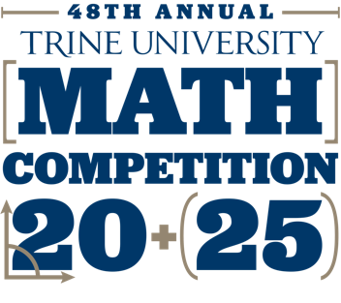

**SCHEDULE OF EVENTS**

8:45 - 9:15 Registration & Continental Breakfast – West Entrance - Hershey Hall Mezzanine. Instructors will receive their schools items. Proceed to the main floor gym.

## FOOD and DRINK must remain in the lobby area.

9:15 - 9:20 Main Floor Welcome

Lauren Decker, Chair of Mathematics and Actuarial Science welcomes the schools and delivers instructions.

9:20 – 9:30 L**eave all electronic devices, papers/books other than wristband and schedules, with teacher/escort before proceeding to the exam rooms. Disqualification from all competition exams if you use any calculator/music/phone/ translator/computer/electronic device/watch, papers/books**.

* Last chance to use the restroom if needed
* Proceed to your assigned location for the team competition quickly.
* Place wristband on
* Exams will be on the table in the room you're assigned to. Leave tests upside down until instructed to begin! Proctors will wander through the rooms. Ask a proctor for pencils as needed. Please remain quiet during the exams.

9:30 – 10:00 Team Competition. Schools A – L East Gym. Schools M – Z in West Gym

When you finish, turn your exam face down on the table and sit quietly until the competition is over. Your exam will be collected before you are dismissed.

10:00 - 10:15 After the end of the team competition, you will be directed to the lobby area. This is a very short intermission for restrooms and beverages. Please remain in the lobby until you are told to proceed to your individual locations.

10:15 - 10:50 Individual Competition: Advanced - West Gym

Intermediate - East Gym

* Clearly print your **full name and your school** at the top of ***every*** page of the exam.
* SHOW ALL WORK. Solutions showing answers only do not earn full credit.
* When you finish, turn your exam face down on the table and sit quietly until the competition is over at 10:50. When everyone is finished, we will collect your test by school

11:00 – 12:15 Lunch in Whitney Commons Café, University Center. Students can tour the campus and visit the Campus Store in the University Center during the lunch break.

12:15 – 1:00 Fabiani Theater - Admissions staff & Math Department Presentation

1:00 Awards & Departure

Thanks for coming. We hope you enjoyed the competition.

It was a pleasure to have you on our campus.